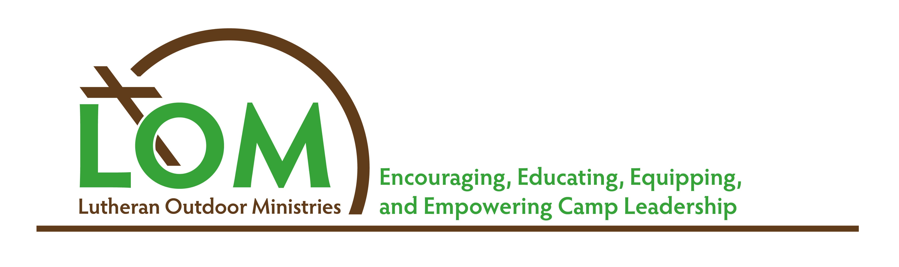

Executive Directors

These results were compiled from a voluntary survey open to all year-round employees of Lutheran Outdoor Ministries sites in April 2015.

For this analysis we combined salary along with housing, medical and pension benefits to define a value we called Compensation.

Compensation = salary + housing ($12,000 unless otherwise indicated) + medical benefits ($6,000[self]/$16,665[family] unless otherwise indicated) + pension benefits.

Number of Respondents: 42 (1 respondent was part time without a salary and 1 respondent did not indicate years of experience.)

1. Average Compensation: $83,657.03

2. Average compensation by years of experience in outdoor ministry:
1-2 years | 3-5 years | 6-10 years | 11-15 years | 16-20 year | 21+ years
$84,000 | $72,007 | $67,717.50 | $88,222.70 | $95,749.50 | $88,261.69

3. Years of full-time experience in outdoor ministry:
1-2 years | 3-5 years | 6-10 years | 11-15 years | 16-20 year | 21+ years
2 | 5 | 6 | 10 | 4 | 14
68% have at least 11 years of full-time outdoor ministry experience.

4. Average compensation by region:
East | Midwest | South | West Coast/Mtns
$77,753 | $84,781 | $91,252 | 85,741
11 | 21 | 5 | 5

5. Average compensation by organizational budget:
> $1,000,001 | $751,000 - $1,000,000 | $500,001 - $750,000 | $250,001 - $500,000 | < $250,000
$102,100 | $90,777 | $74,983 | $71,996 | $58,683
14 | 6 | 8 | 8 | 6

6. 60% hold a Master’s Degree. 100% hold a Bachelor’s Degree.

7. 29% are Rostered. 21% are Rostered Clergy.

8. 40% receive housing or a housing stipend as part of the compensation package.

9. 81% receive medical insurance. (64% Family, 17% Self)

10. 86% receive continuing education funding averaging $1,483.

11. 40% have a sabbatical policy in place. Most common 3 months after 7 years.

12. 90% of executive directors that responded are Male

13. LOM LTE: 48% Program; 55% Administrative; 38% both

14. Budget >$1,000,001 and years of experience:
1-2 years | 3-5 years | 6-10 years | 11-15 years | 16-20 year | 21+ years
1 | 1 | 0 | 3 | 4 | 4
85% of Executives have at least 11 years of full-time outdoor ministry experience.

15. Budget $750,001 - $1,000,00 and years of experience:
1-2 years | 3-5 years | 6-10 years | 11-15 years | 16-20 year | 21+ years
1 | 1 | 0 | 2 | 0 | 2
67% of Executives have at least 11 years of full-time outdoor ministry experience.

16. Budget $500,001 - $750,000 and years of experience:
1-2 years | 3-5 years | 6-10 years | 11-15 years | 16-20 year | 21+ years
0 | 0 | 3 | 3 | 0 | 2
62.5% of Executives have at least 11 years of full-time outdoor ministry experience.
100% have at least 6 years

17. Budget $250,001 - $500,000 and years of experience:
1-2 years | 3-5 years | 6-10 years | 11-15 years | 16-20 year | 21+ years
0 | 0 | 1 | 2 | 0 | 5
87.5% of Executives have at least 11 years of full-time outdoor ministry experience.
100% have at least 6 years

18. Budget <$250,000 and years of experience:
1-2 years | 3-5 years | 6-10 years | 11-15 years | 16-20 year | 21+ years
0 | 3 | 2 | 0 | 0 | 0
0% of Executives have at least 11 years of full-time outdoor ministry experience.
100% have less than 10 years

Site & Associate Directors

These results were compiled from a voluntary survey open to all year-round employees of Lutheran Outdoor Ministries sites in April 2015.

For this analysis we combined salary along with housing, medical and pension benefits to define a value we called Compensation.

Compensation = salary + housing ($3000-$7000 depending on amenities listed) + medical benefits ($6000[self]/$16,665[family]) + pension benefits.

Number of Respondents: 15

1. Average compensation: $48,444

2. Average compensation by years of experience in outdoor ministry (FTE):
1-2 years | 3-5 years | 6-10 years | 11-15 years | 16-20 year | 21+ years
$36,888 | $59,275 | $58,5195 | $52,000 | $55,738 | $54,577
6 | 1 | 3 | 1 | 1 | 3
50% of 1-2 years are Full-Time.

3. Average compensation by organizational budget:
> $1,000,001 | $751,000 - $1,000,000 | $500,001 - $750,000 | $250,001 - $500,000 | < $250,000
$55,306 | $58,665 | $48,000 | $44,088 | $36,165
10 | 1 | 2 | 1 | 1

4. 13% hold a Master’s Degree. 100% hold at least a Bachelor’s Degree.

5. 13% are Rostered. 0% Rostered Clergy.

6. 33% receive housing or a housing stipend as part of the compensation package.
> $1,000,001 | $751,000 - $1,000,000 | $500,001 - $750,000 | $250,001 - $500,000 | < $250,000
10% | 100% | 50% | 100% | 100%

7. 67% receive medical insurance. (50% Family, 50% Self)

8. 67% receive pension benefits averaging $2,529 per year.

9. 80% receive continuing education funding averaging $642.

10. 33% have a sabbatical policy in place. Most common 2-3 months after 7 years or 1-2 months after 5 years.

11. 53% of Site/Associate Directors that responded are female.

12. Years of full-time experience in outdoor ministry:
1-2 years | 3-5 years | 6-10 years | 11-15 years | 16-20 year | 21+ years
6 | 1 | 3 | 1 | 1 | 3
47% have less than 6 years of full-time outdoor ministry experience.

13. 40% have attended the Program Track LTE; 40% have attended the Admin Track LTE; 20% have attended both.

Program Directors

These results were compiled from a voluntary survey open to all year-round employees of Lutheran Outdoor Ministries sites in April 2015.

For this analysis we combined salary along with housing, medical and pension benefits to define a value we called Compensation.

Compensation = salary + housing ($3000-$7000 depending on amenities listed) + medical benefits ($6000[self]/$16,665[family]) + pension benefits.

Number of Respondents: 17

1. Average compensation: $46,000

2. Average compensation by years of experience in outdoor ministry:
1-2 years | 3-5 years | 6-10 years | 11-15 years | 16-20 year | 21+ years
$38,691 | $49,401 | $48,323 | $53,832 | - | $58,032
7 | 2 | 4 | 1 | 0 | 2

3. Average compensation by organizational budget:
> $1,000,001 | $751,000 - $1,000,000 | $500,001 - $750,000 | $250,001 - $500,000 | < $250,000
$47,158 | $51,282 | $40,650 | $37,000 | -
8 | 4 | 4 | 1 | 0

4. 17% hold a Master’s Degree. 100% hold at least a Bachelor’s Degree.

5. 0% are Rostered.

6. 65% receive housing or a housing stipend as part of the compensation package.
> $1,000,001 | $751,000 - $1,000,000 | $500,001 - $750,000 | $250,001 - $500,000 | < $250,000
37% | 75% | 100% | 100% | -

7. 95% receive medical insurance. (31% Family, 69% Self)

8. 65% receive pension benefits averaging $2,529 per year.

9. 65% receive continuing education funding averaging $764.

10. 30% have a sabbatical policy in place. Most common 3 months after 7 years or
1 month after 5 years.

11. 69% of program directors that responded are female.

12. Years of full-time experience in outdoor ministry:
1-2 years | 3-5 years | 6-10 years | 11-15 years | 16-20 year | 21+ years
7 | 2 | 4 | 1 | - | 2
53% have less than 6 years of full-time outdoor ministry experience.

13. 65% have attended the Program Track LTE; 35% have attended the Admin Track LTE; 30% have attended both.

